

**Project Report Template**

1. **INTRODUCTION** 
   1. **Overview**

The hotel industry is a broad category of businesses that provide lodging services for travellers and tourists. This can include a wide range of establishments, from luxury resorts to budget-friendly motels, as well as extended stay hotels, boutique hotels, and more. Hotels can be found in nearly every corner of the world, and are often a major component of the tourism and travel industry in a given area. Radisson owns multiple five-star hotels across India. They have been in the hospitality industry for the past 100 years. Due to strategic moves from other competitors and ineffective decision-making in management, Radisson is losing its market share and revenue in the luxury/business hotels category. As a strategic move, the managing director of Radisson wanted to incorporate Business and Data Intelligence in order to regain their market share and revenue. Our task is to create an analytics dashboard & story to provide them insights to make better business decisions

* 1. **Purpose**

At Radisson Hotel Group we strive to be the first choice in the mind of guests, owners and talent. In our journey to achieve this, we practice strong beliefs and actions that respect the diversity of people, the community, ethics and the planet.

**2 Problem Definition & Design Thinking**

2.1 **Empathy Map**

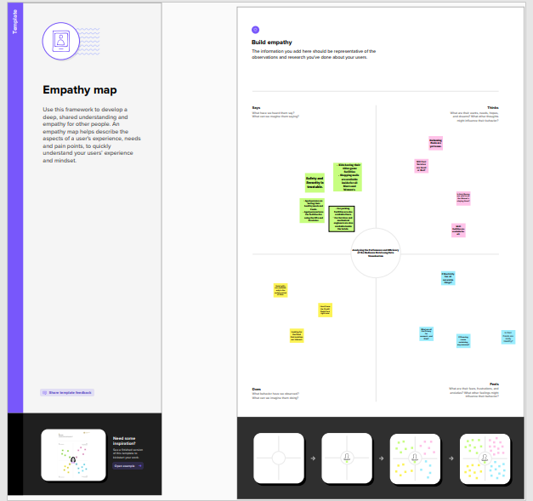

2.2 **Ideation & Brainstorming Map**

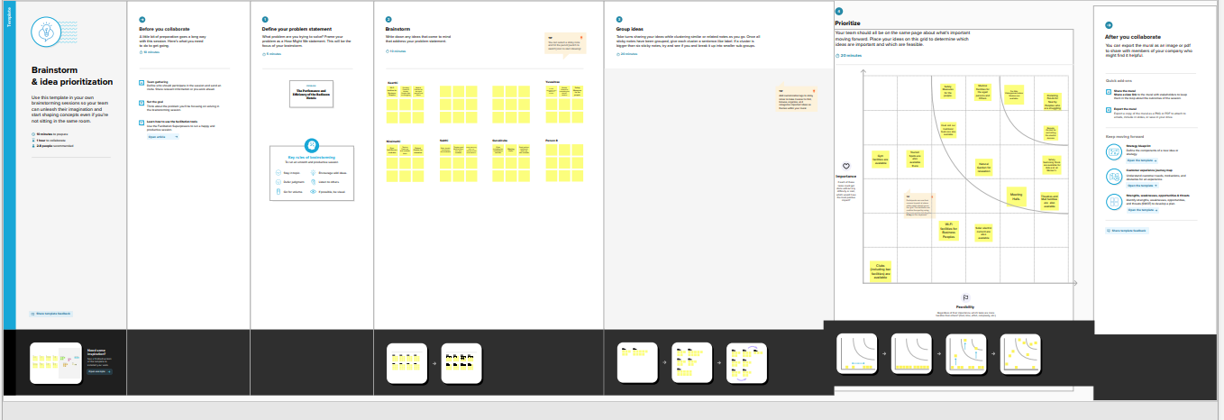

1. **RESULT**

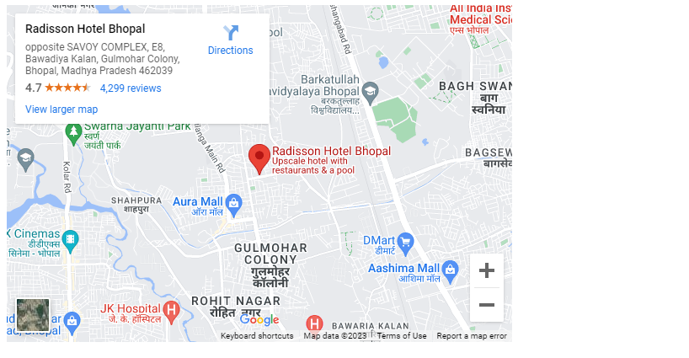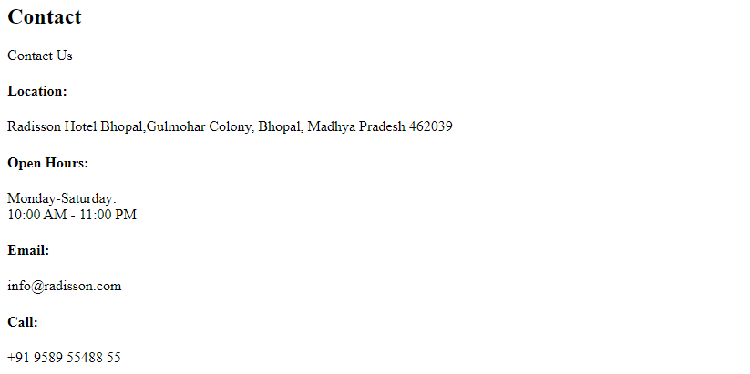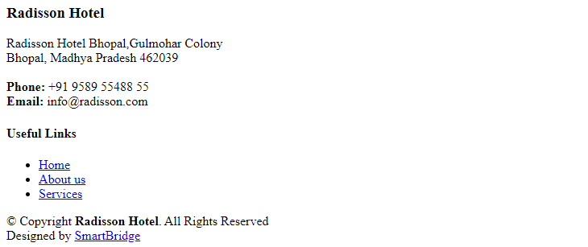.

1. **ADVANTAGES & DISADVANTAGES**

**Advantage** :

1. All facilities are available in the Radisson hotels
2. Water facilities are necessary here.

**Disadvantage** :

1.security should be prohibited mainly for womens and family members

2.Electric accidents are happening

1. **APPLICATIONS**

Radisson owns multiple five-star hotels across India. They have been in the hospitality industry for the past 100 years. Due to strategic moves from other competitors and ineffective decision-making in management, Radisson are losing its market share and revenue in the luxury/business hotels category. As a strategic move, the managing director of Radisson wanted to incorporate Business and Data Intelligence in order to regain their market share and revenue.

1. **CONCLUSION**

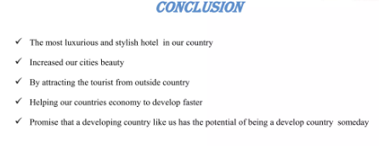

1. **FUTURE SCOPE**

All equipments were controlled by the remote control devices

1. **APPENDIX**

A. Source Code

